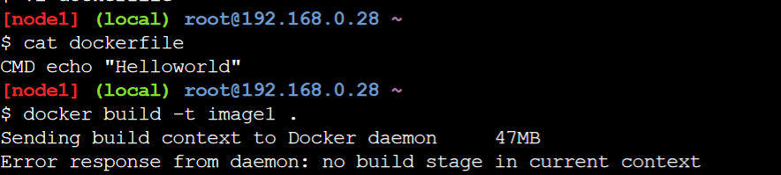

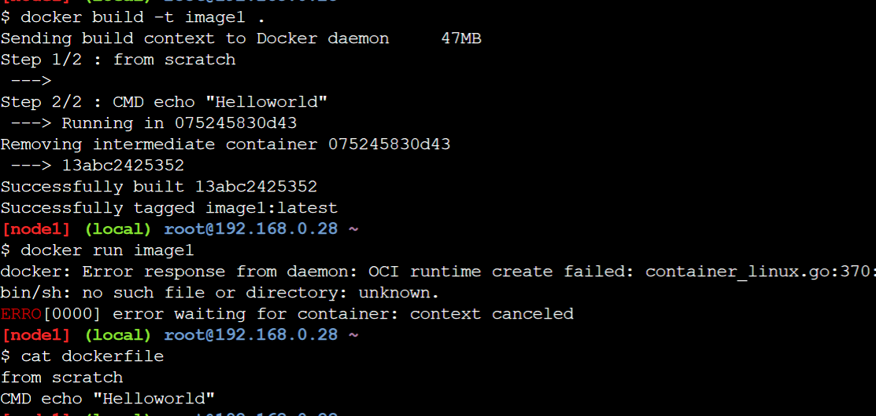

It’s approximately impossible to create multiOS docker image because we need to specify from statement for base image selection.

FROM ubuntu CMD ping google.com

If our goal is only to achieve MultiOS docker file, we can write image from scratch/ONBUILD.